**Annexure-I**

**Zippy Foods**

**A Mini-Project Report**

**Under**

**Project Workshop**

***Submitted by***

**Samarth Sarin**

***Under The Guidance Of***

***Professor Ratnesh Chaturvedi***

***in partial fulfillment for the award of the degree***

***of***

**Btech**

**Computer Science**

**At**

**Svkm’s Nmims, vile parle(w)**



**April 2015**

**Annexure-II**

**CERTIFICATE**

This is to certify that the project entitled “ Zippy Food ” is the bonafide work carried out by Samarth Sarin of B.Tech (Computer Engineering), MPSTME (NMIMS), Mumbai, during the IV semester of the academic year 2015, in partial fulfillment of the requirements for the award of the Degree of Bachelors of Technology as per the norms prescribed by NMIMS. The mini-project work has been assessed and found to be satisfactory.

___________________

Prof Ratnesh Chaturvedi

Internal Mentor

_______________________ ________________________

Examiner 1 Examiner 2

________________________

Dean

Dr. D.J. Shah

**Annexure-III**

**DECLARATION**

We, <B.Kartik Rao, Samarth Sarin, Akriti Sharma, Utkarsh Singh>, Roll Nos: <E033,E035,E039,E044> of B.Tech (Computer Engineering), IV semester understand that plagiarism is defined as anyone or combination of the following:

1. Un-credited verbatim copying of individual sentences, paragraphs or illustration (such as graphs, diagrams, etc.) from any source, published or unpublished, including the internet.
2. Un-credited improper paraphrasing of pages paragraphs (changing a few words phrases, or rearranging the original sentence order)
3. Credited verbatim copying of a major portion of a paper (or thesis chapter) without clear delineation of who did wrote what. (Source: IEEE, The institute, Dec. 2004)
4. I have made sure that all the ideas, expressions, graphs, diagrams, etc., that are not a result of my work, are properly credited. Long phrases or sentences that had to be used verbatim from published literature have been clearly identified using quotation marks.
5. I affirm that no portion of my work can be considered as plagiarism and I take full responsibility if such a complaint occurs. I understand fully well that the guide of the seminar/ project report may not be in a position to check for the possibility of such incidences of plagiarism in this body of work.

Signature of the Students:

Name: B.Kartik Rao, Samarth Sarin, Akriti Sharma, Utkarsh Singh

Roll No: E033, E035, E039, E044

Place: SVKM’s NMIMS

Date: 22 April, 2015

**ACKNOWLEDGEMENTS**

In performing our assignment, we had to take the help and guideline of some respected persons, who deserve our greatest gratitude. The completion of this assignment gives us much Pleasure. We would like to show our gratitude to Professor Ratnesh Chaturvedi for giving us a good guideline for assignment throughout numerous consultations. We would also like to expand our deepest gratitude to all those who have directly and indirectly guided us in writing this assignment.

We would also like to thank our esteemed college officials for giving us this incredible opportunity to showcase our efforts.

Many people, especially our classmates and team members itself, have made valuable comment suggestions on this proposal which gave us an inspiration to improve our assignment. We thank all the people for their help directly and indirectly to complete our assignment.

**Brief Description/Preface**:

At Zippy Food it is our aim to take your restaurant experience to an entirely new and automated level.

To achieve this we have designed an application currently supported with android using which you can place your order quickly and without any hassles of placing your order and experiencing your delicious food with just a few taps.

Our application Zippy Foods will help you place your order, book a table without being put on a hold by the hotel personnel. Zippy Foods will let you directly place your order and book a table. The app will eliminate the need of a waiter to take your order. You can directly convey your order to the chef and experience your drooling food in a few moments.

**Annexure IV**

**Table of contents**

**CHAPTER NO. TITLE PAGE NO.**

1. Review of literature 10

* 1. Implementing through android studio 10
  2. Application 11
  3. Specifications 12

1. Detailed Analysis/Design 13
   1. Analysis 13
   2. Android Client 15
   3. Server Client 17
2. Miscellaneous 18
   1. Features 18
   2. Application 18
   3. Advantages 18
   4. Current Status 19
   5. Few Screenshots 23
   6. Evolution of app 27
3. References 28

**Annexure V**

**List of Figures**

**CHAPTER NO. TITLE PAGE NO.**

1. Server Client 14
2. Android Client 15,16
3. Current Status 19-22
4. Screenshots 23-26 , 27

**Annexure VI**

**List of Tables**

**CHAPTER NO. TITLE PAGE NO.**

1. System Requirements 10

2. Server Client 17

**Annexure VII**

**Abbreviations**

None used whatsoever.

**1)Review Of Literature:**

**1.1)Implementing through Android Studio**

**Android Studio** is an [integrated development environment](http://en.wikipedia.org/wiki/Integrated_development_environment) (IDE) for developing on the [Android](http://en.wikipedia.org/wiki/Android_(operating_system)) platform. It was announced on May 16, 2013 at the [Google I/O](http://en.wikipedia.org/wiki/Google_I/O) conference by [Google](http://en.wikipedia.org/wiki/Google)'s Product Manager, Ellie Powers. Android Studio is freely available under the [Apache License 2.0](http://en.wikipedia.org/wiki/Apache_License).

Android Studio was in early access preview stage starting from version 0.1 in May 2013, then entered beta stage starting from version 0.8 which was released in June 2014. The first stable build was released in December 2014, starting from version 1.0.

**System requirements**

|  |  |  |  |
| --- | --- | --- | --- |
|  | **Windows** | **OS X** | **Linux** |
| **OS version** | Microsoft Windows 10/8.1/8/7/Vista/2003/Xp (32 or 64 bit) | Mac OS X 10.8.5 or higher, up to 10.10 to up 10.10.2 up 10.10.3 (Yosemite) | GNOME or KDE or Unity desktop on Ubuntu or Fedora or GNU/Linux Debian |
| **RAM** | 2 GB RAM minimum, 4 GB RAM recommended | | |
| **Disk space** | 500 MB disk space | | |
| **Space for Android SDK** | At least 1 GB for Android SDK, emulator system images, and caches | | |
| **JDK version** | Java Development Kit (JDK) 7 or higher | | |
| **Screen resolution** | 1280x800 minimum screen resolution | | |

It is after using this platform, we were able to implement our app and get it to perform successfully.

Android Studio gave us the required tools needed to create our app.

**1.2)Application:**

**Application Name:**

Zippy Food

**Brief Description:**

The Restaurant App is a mobile reservation system that used for managing reservation and restaurant menu. Admin can manage reservation, restaurant menu and other configurations such as tax and currency code from admin panel on the web and users will be able to see the menu from mobile app and make a reservation. Run under Android platform which is the number one popular mobile operating system right now this app comes with many features. This app will save your time in creating an app for the restaurant of yours or your client.

To achieve this we have designed an application currently supported with android using which you can place your order quickly and without any hassles of placing your order and experiencing your delicious food with just a few taps.

Our application Zippy Foods will help you place your order, book a table without being put on a hold by the hotel personnel. Zippy Foods will let you directly place your order and book a table. The app will eliminate the need of a waiter to take your order. You can directly convey your order to the chef and experience your drooling food in a few moments.

**1.3)Specifications:**

Minimum requirements

1. 512 Mb RAM
2. Android O.S Gingerbread (2.3.3)
3. 20 Mb : On Device Storage
4. Working internet connection
5. 1 GHz processor
6. No control over what other Apps user might run , thus required RAM should be available for an error free and no crash environment.

Optimal/Recommended requirements

1. 1 Gb RAM
2. Android O.S Kitkat (4.4)
3. 50-75 Mb : On Device Storage
4. Internet connection
5. 1 Ghz processor

**2) Detailed Analysis/Design**

**2.1) Analysis**

The application is designed with strict separation of concerns following a 3-tier architecture model. Each tier is insulated from others using a well-defined interface, resulting in a design where there is zero dependency among the tiers.

ANDROID CLIENT

The interaction between the user and the app takes place at this level. It is here where the user places his/her order.

All the activities are done here i.e selection of your food, pondering your choice over and then finally ordering it.

Then it is passed to the server client.

SERVER CLIENT

After the user places his/her order he/she receives a notification that their order has been placed and then is proceeded to place it at the restaurant of choice.

The server receives a notification from the user stating their choice of menu for the night and is then cooked and served accordingly.

The following diagram gives the interface architecture:



**2.2) Android Client**

The android client interacts with user via a set of activities. Below is a subset of such activities , in terms of user interaction. Included are basic purpose and screenshots;

a)

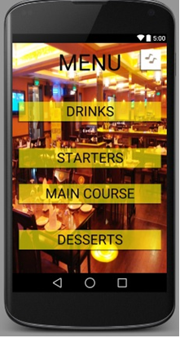

The menu choice where the user may select his/her choice of the food .

b)

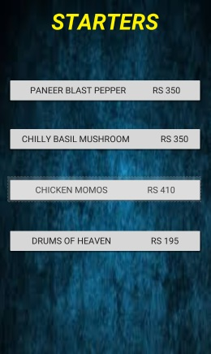

Upon opening one of the pages the user is presented with the options and a palette from where he/she would want to order. Dishes selected by the users are then added to cart.

c)

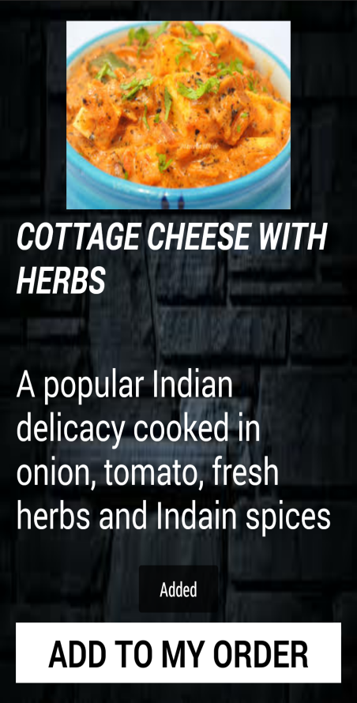

After the order is placed the user can then navigate to the cart and place their order.

**2.3) Server Client**

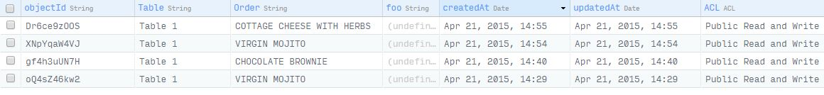

The above picture / screenshot shows the order being placed and received at the receiver’s side.

We propose to have this at the restaurant management level wherein one can check the orders placed and do the needful accordingly.

**3)MISCELLANEOUS**

**3.1)FEATURES:**

* 1. Book a table according to your need without any hassles.
  2. Manage the restaurant efficiently along with the time of placing the order.
  3. Set up menu of restaurant along with sub categories.
  4. Detail description of each dish along with its image, time to prepare it, how many people it will suffice, its price in many currencies.
  5. Easy to use.
  6. Music makes the application more attractive.

**3.2)APPLICATION:**

1. Can be used in various restaurants and help saving man power, salary and time.
2. Its quite useful for all the restaurants and this concept can also be used by any other outlet.

**3.3)ADVANTAGES OF OUR APP:**

1. Fast and easy user interface.
2. Reduces the need of manpower i.e the need of waiters to take orders and hence saves money thereby makes it economic and increases the profit of the hotel management.
3. Reduces the waiting time of the customer and hence speeds up the process.
4. Helps in making the Resturant more advanced and popular in the market.

**3.4)CURRENT STATUS OF OUR APP**

* + 1. We have successfully created the pages of our app and have made the pages very attractive and apt for the app by adding pictures in the back and blended the menu accordingly.

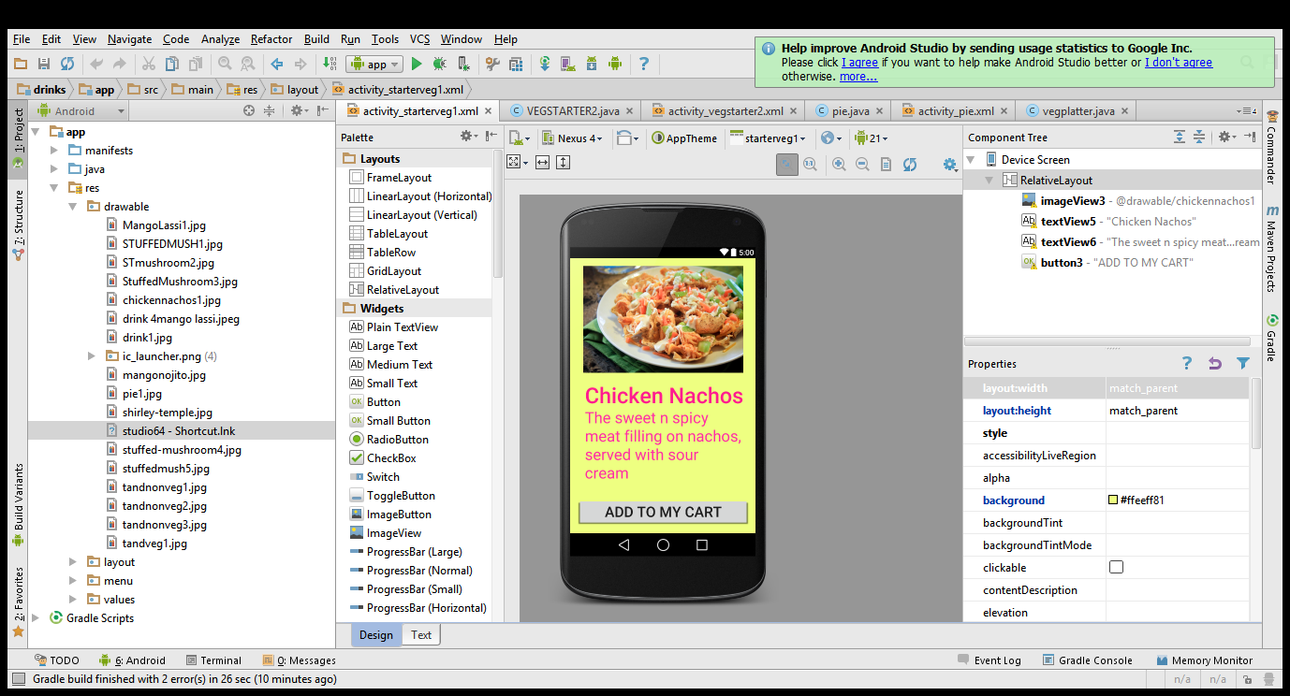 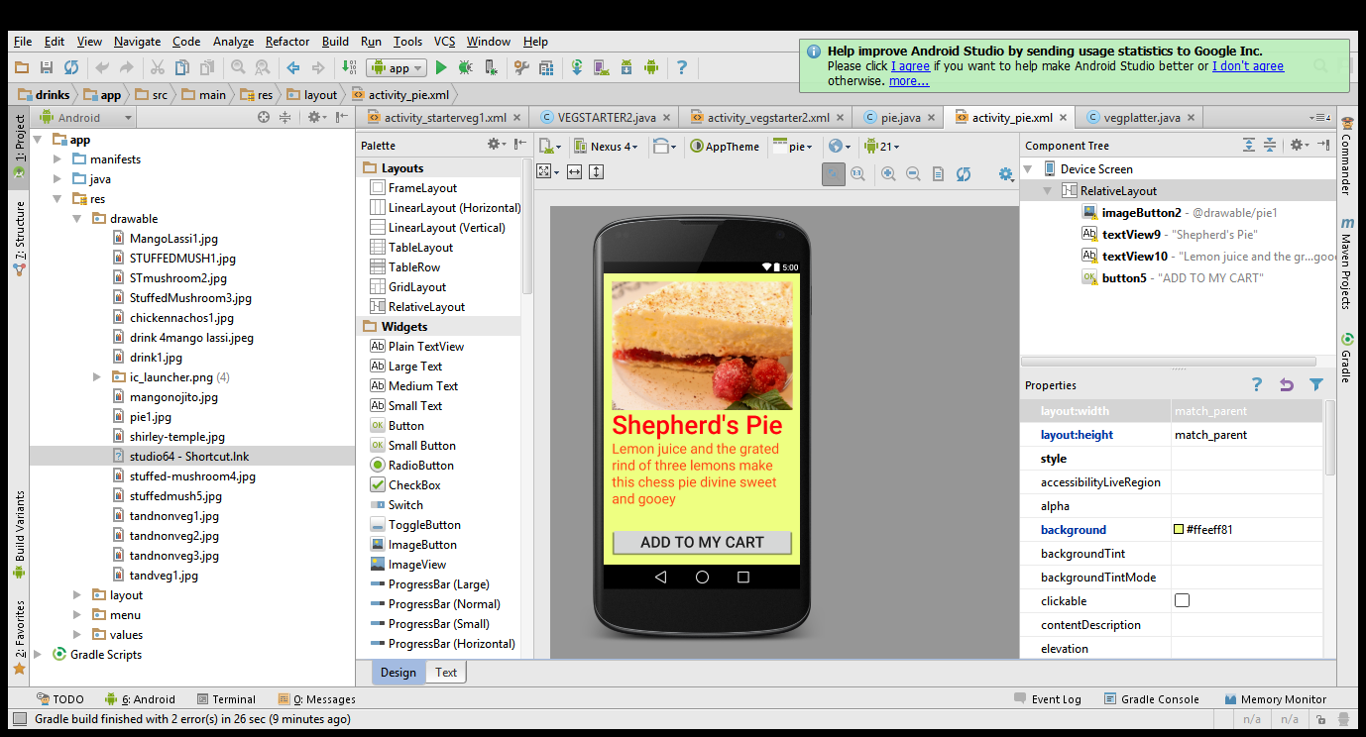

2. We have successfully linked the pages of majority of our app which has made our app functional.

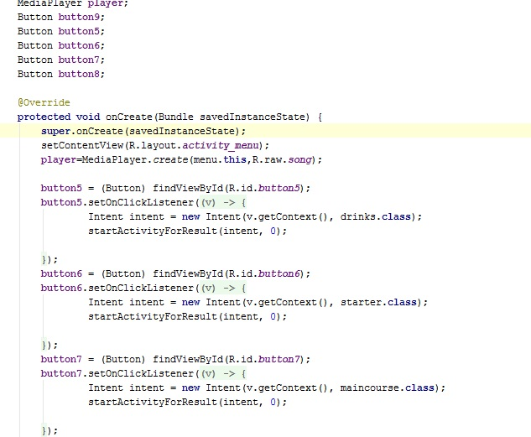

 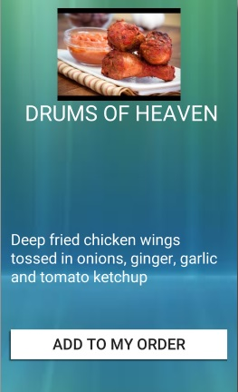

**ADDED A TOAST:**

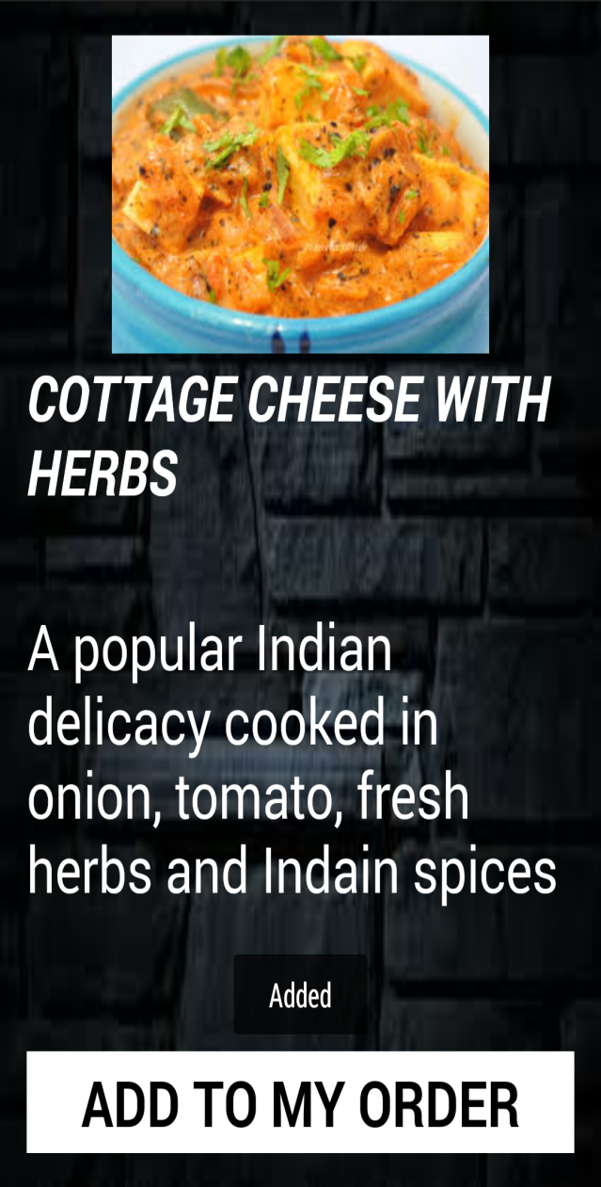

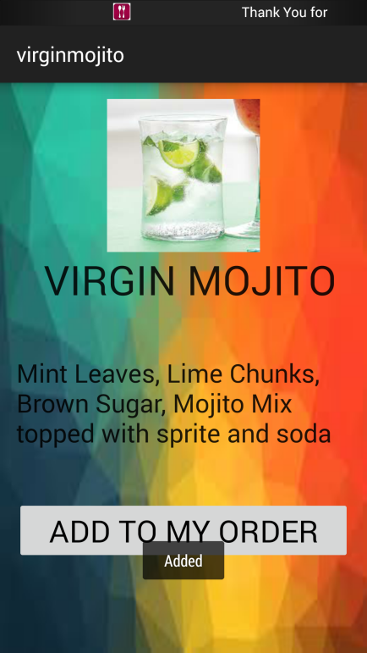

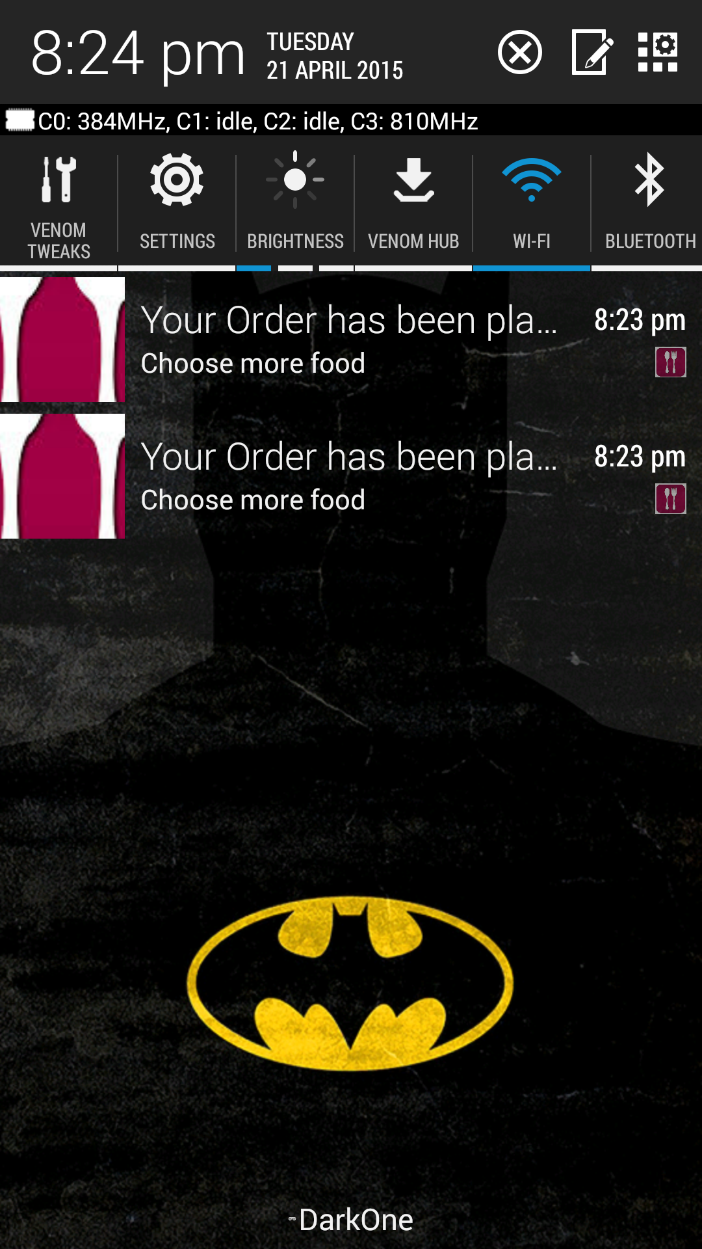

Notification stating the successful processing of our order.

**3.5)FEW SCREENSHOTS**

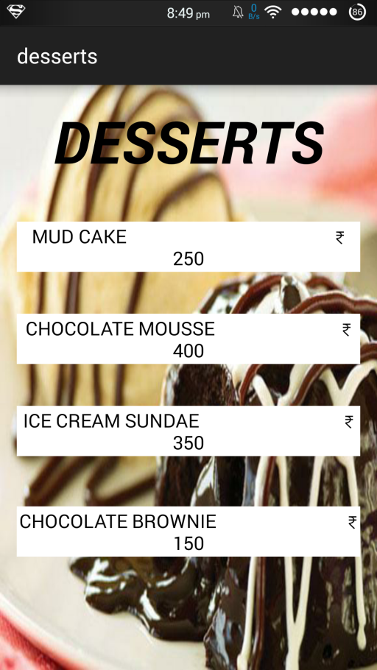

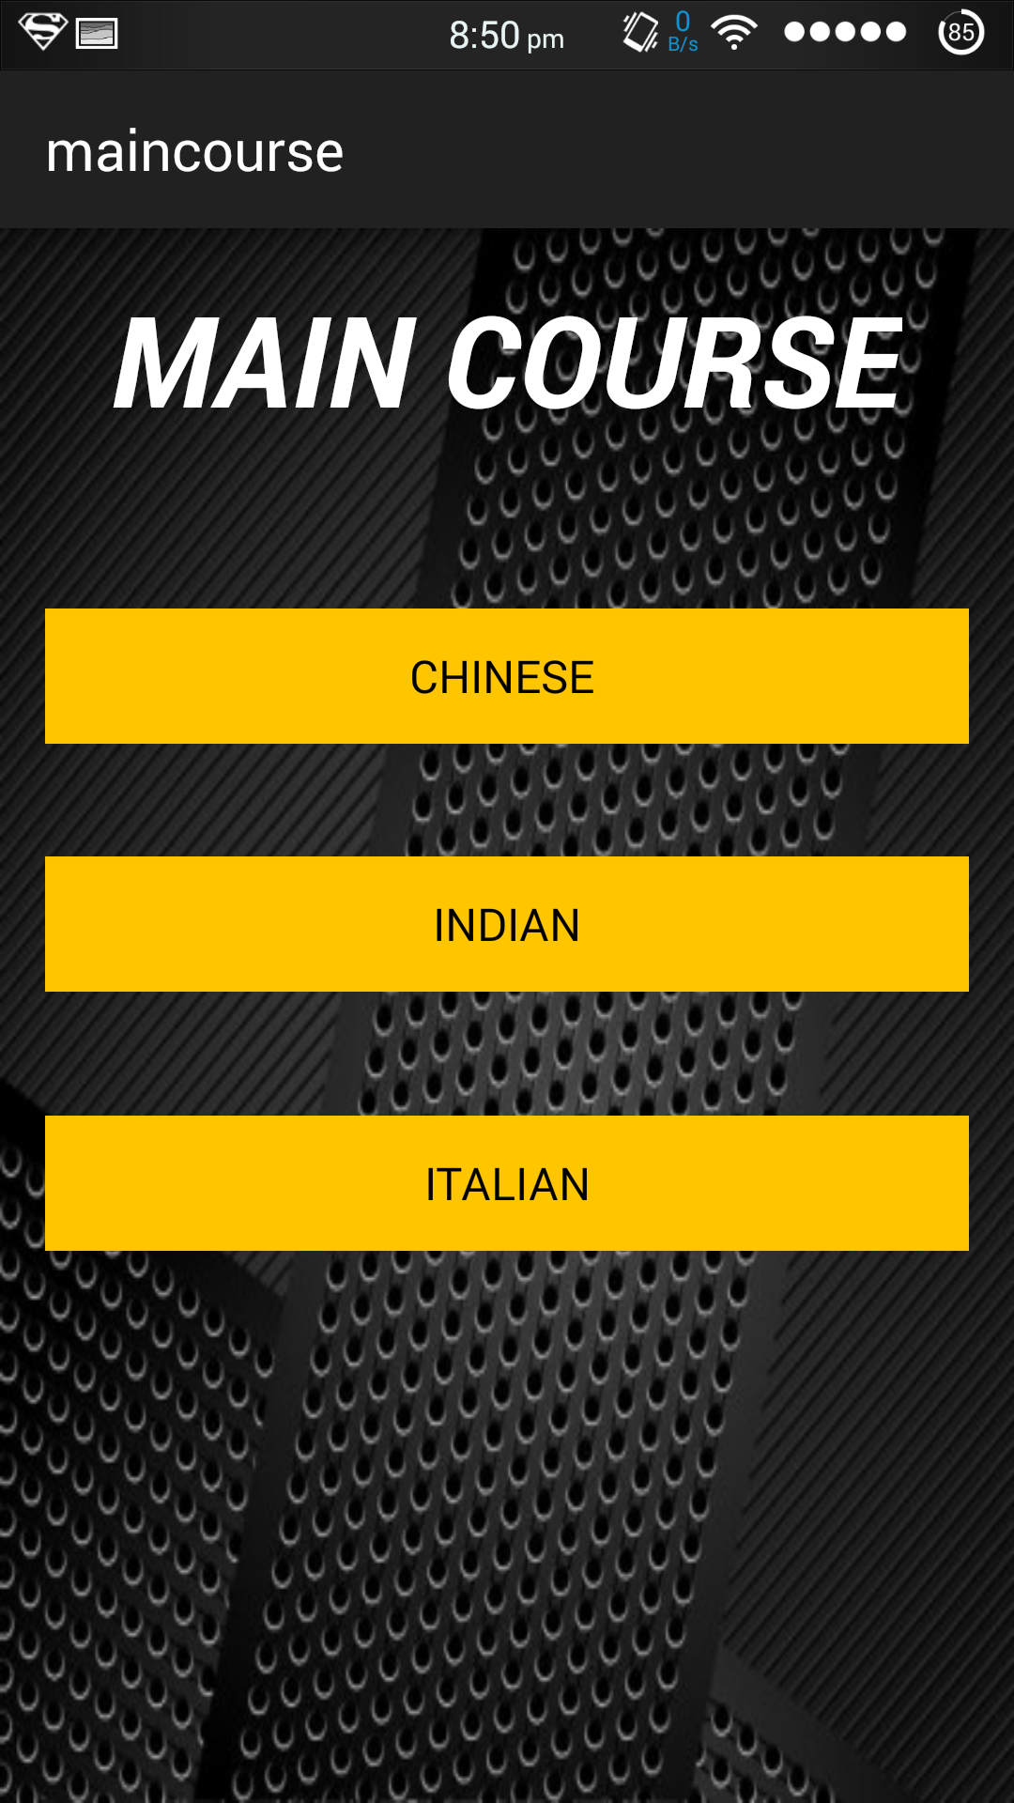

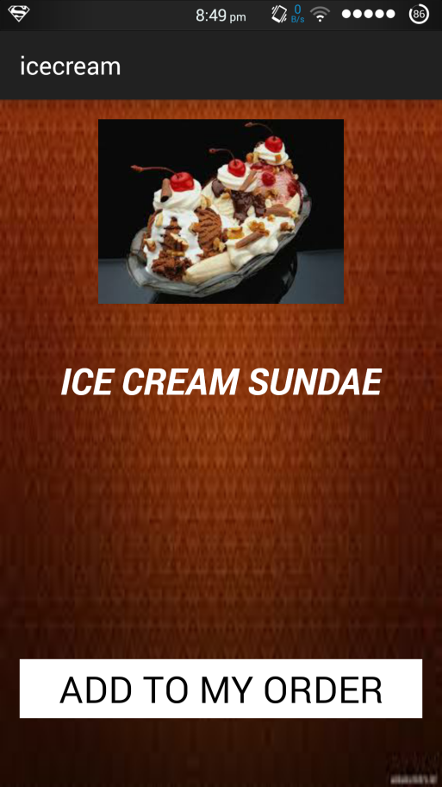

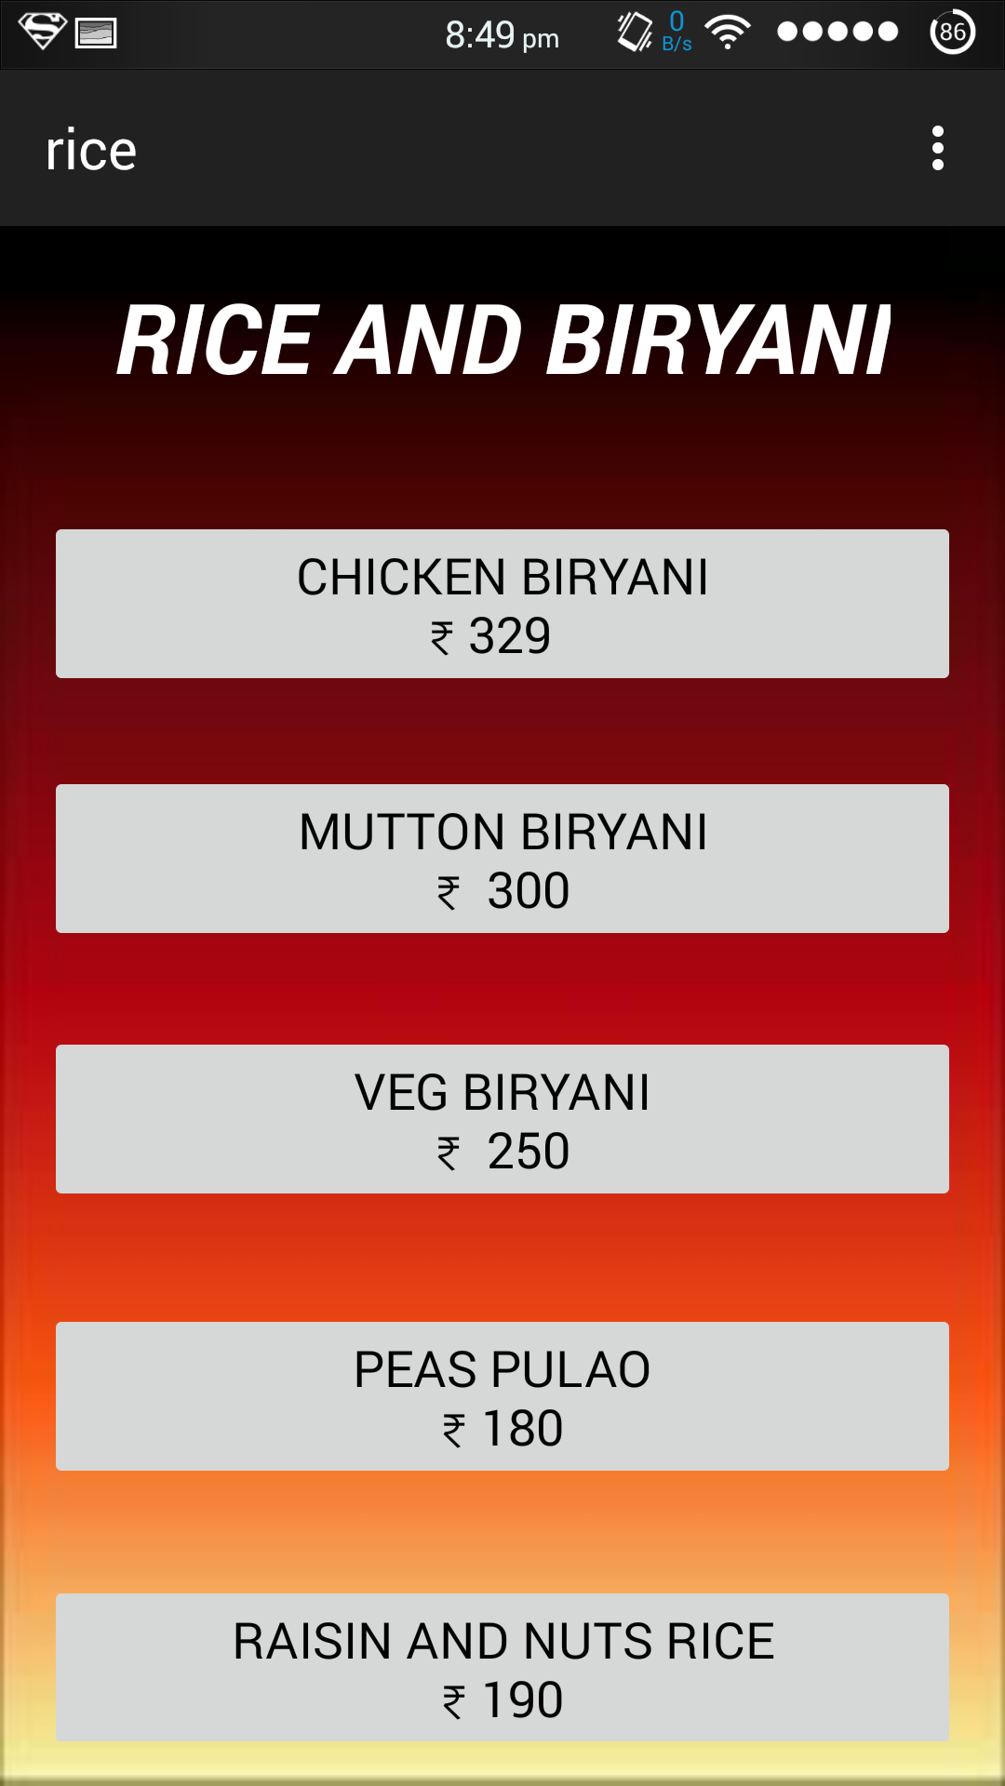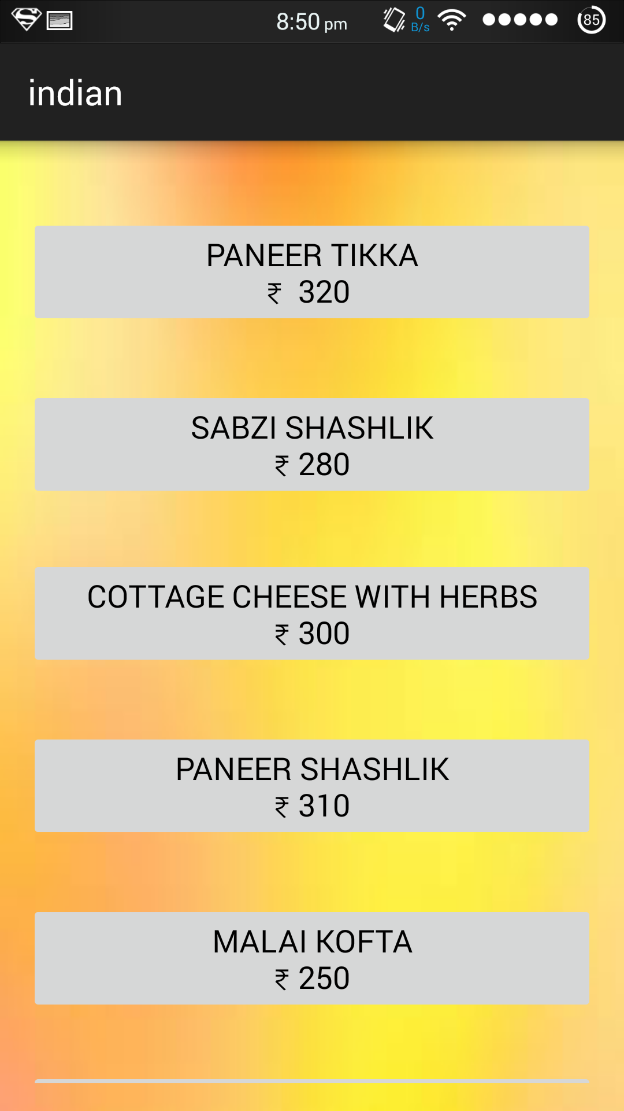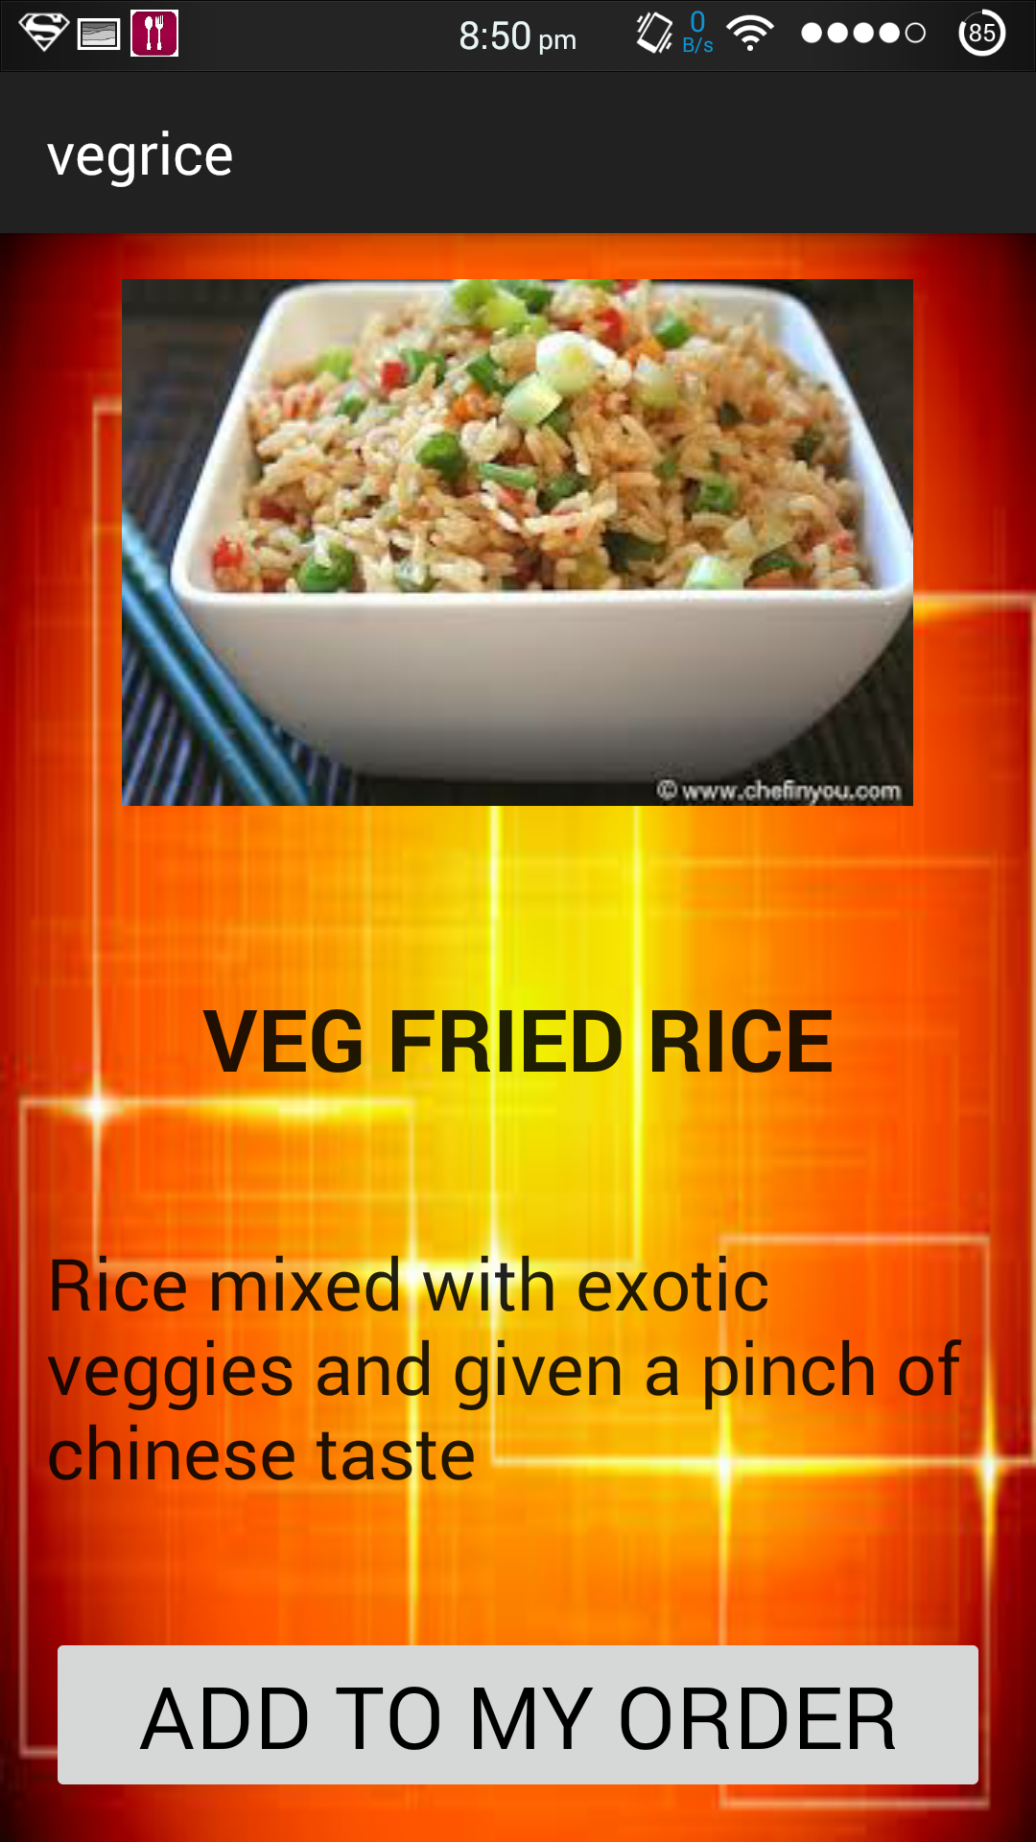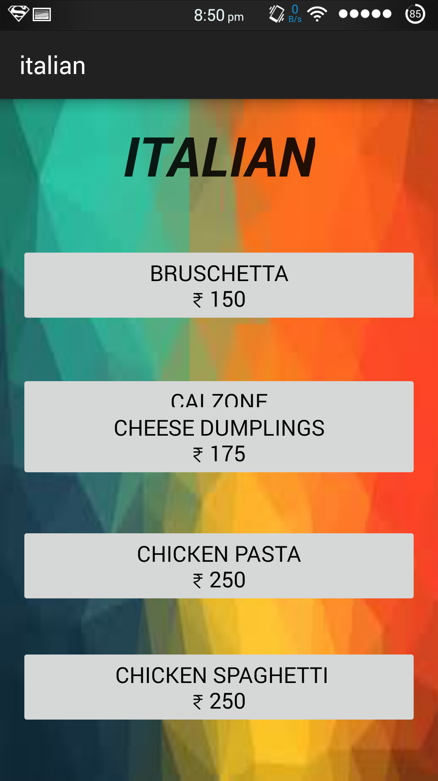

These are a few screenshots showing the various menu items.

For easy use, we have given the cost per item along with the item to be ordered at the very side to provide an easy and a comfortable environment.

**3.6)EVOLUTION OF OUR APP**

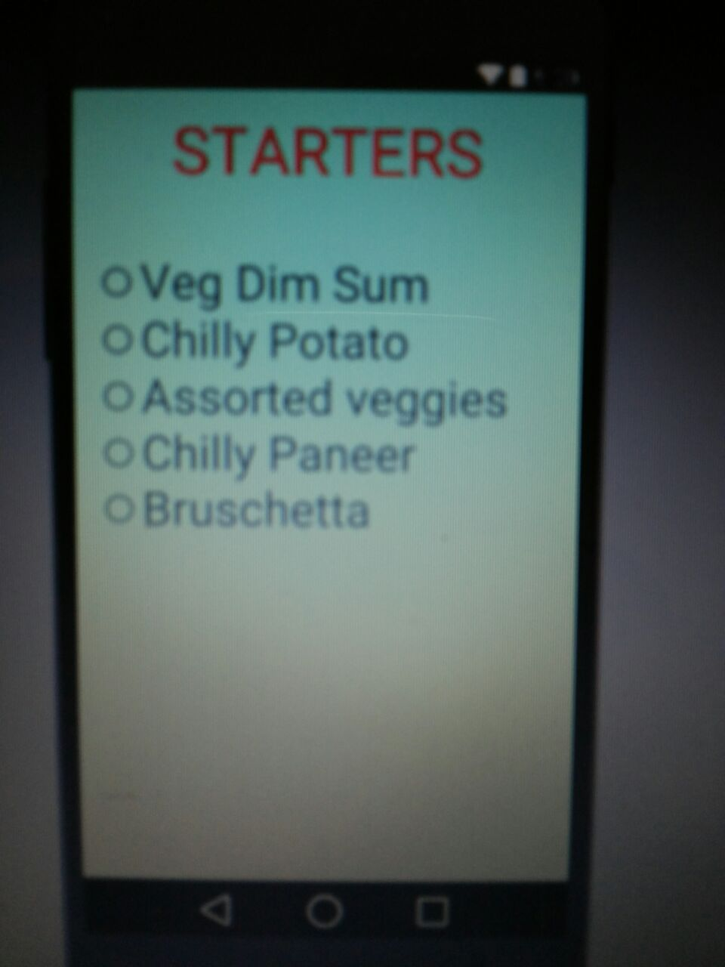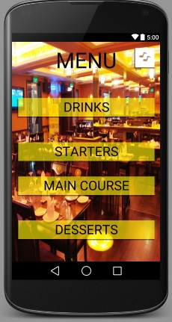

**4)REFERENCES:**

1. <http://stackoverflow.com/>
2. <http://www.mkyong.com/tutorials/android-tutorial/>
3. <http://developer.android.com/index.html>
4. <https://teamtreehouse.com/tracks/android-development>